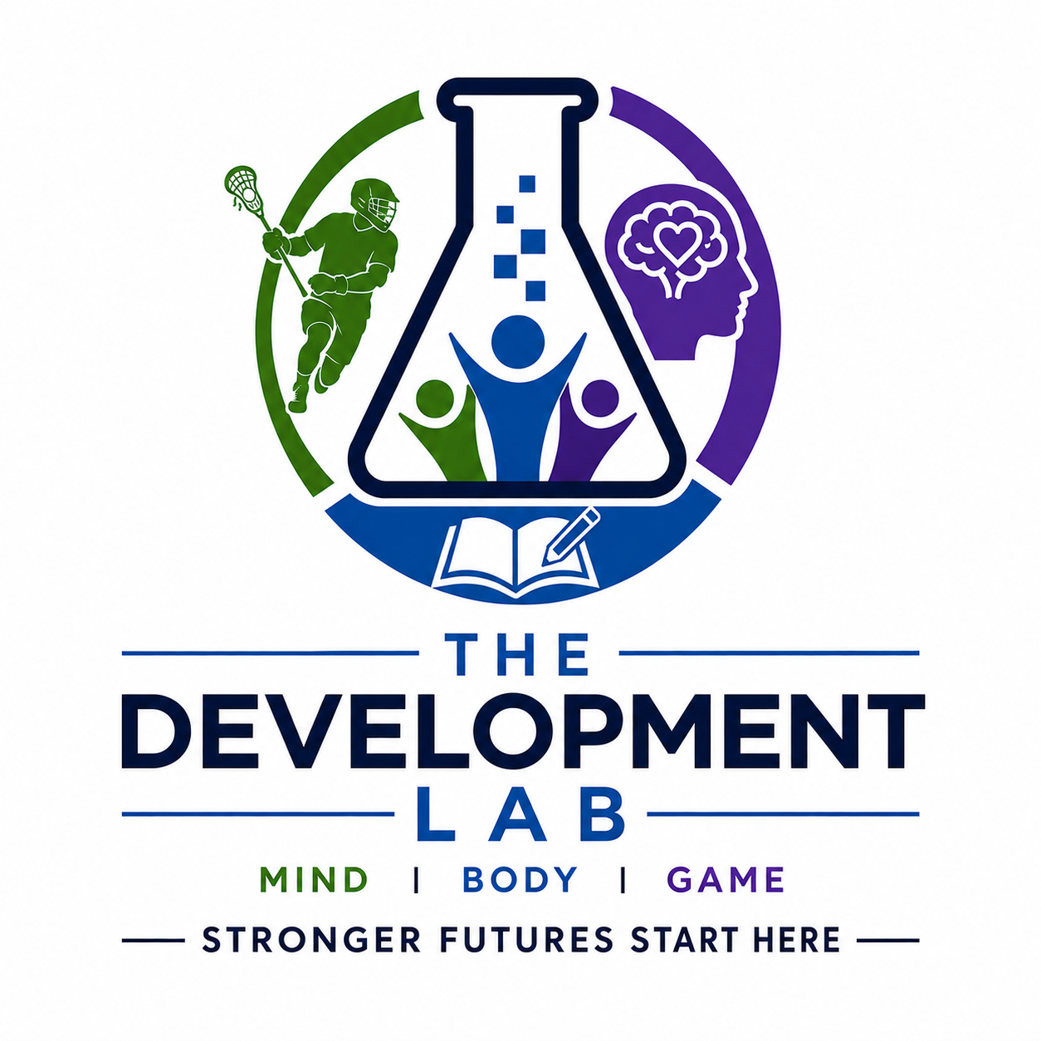

The Development Lab
5.6.2026

Tim Rau
15 Driscoll Avenue
Rockville Centre, NY 11570

Overview
The Development Lab is a youth athlete development platform designed to help families find and engage trusted providers across four core pillars: sport-specific training, speed and agility development, tutoring, and mental performance support. Rather than forcing families to rely on fragmented referrals and disconnected research, the platform aims to create one place to discover, evaluate, and connect with the right specialists. With the youth sports market projected to grow meaningfully through 2030, the long-term opportunity is to build a scalable marketplace that can expand across sports, age groups, and geographies.

Goals
- Deliver both standalone services and bundled memberships so families can engage a single provider or build a more complete athlete development plan through one platform.
- Help families, schools, clubs, and youth programs quickly identify best-fit providers based on needs, budget, geography, and development goals.

Problems We Are Looking to Solve
- Numerous providers in saturated markets make it hard for trainers/tutors to get continued business, or they have to waste resources trying to market for new clients.
  - We will bring customers/clients to providers through our matchmaking algorithm.
- Families have to rely on word of mouth, research, and networking to find the best resources and specialists for their children.
  - We will create a “one-stop shop” that mitigates stress and saves families time to find the resources that they need.

Youth Sports At A Glance

New York Market Space and Projection
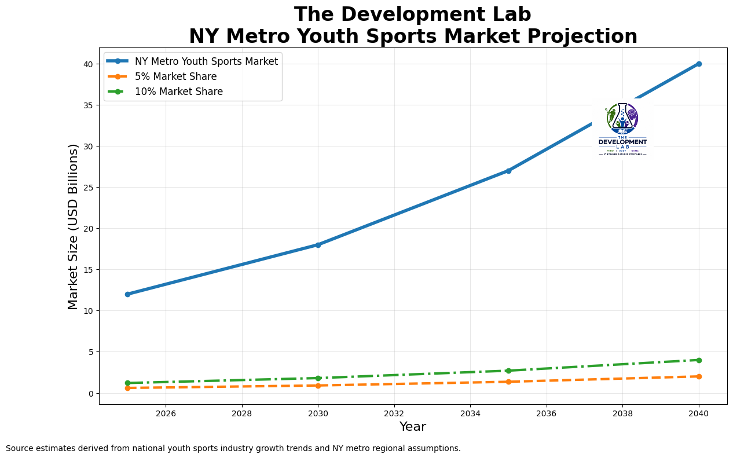

National Market Space and Projection
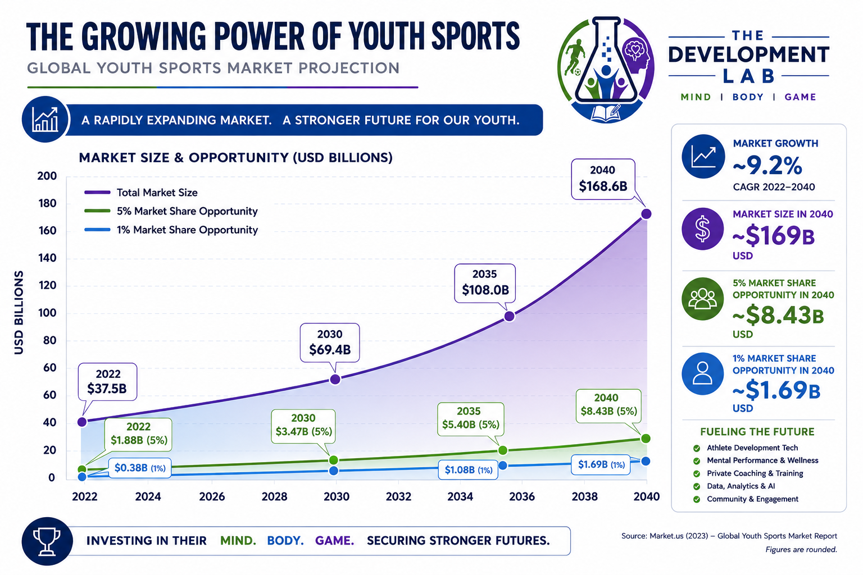

Trends
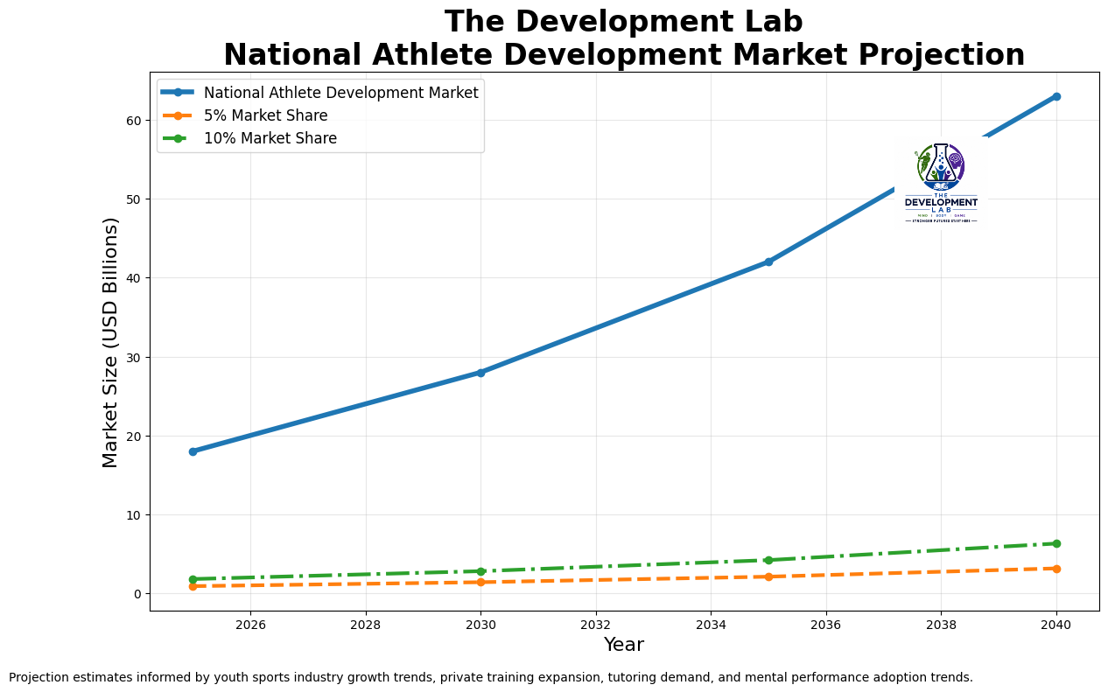

Hurdles
- Securing enough initial capital to fund branding, MVP development, legal setup, and early customer acquisition (estimated $25K-$75K).
- Building brand credibility, launching the technology stack, and formalizing the business infrastructure.
- Recruiting enough high-quality specialists to create a compelling supply base during the pilot phase.

Specifications
- Integrated App/Website Design that houses specialists in all areas and price point ranges
- Targets a family’s specific budget and wants/needs to “match” them with a list of providers that fit their search criteria.
- Utilizing advertising as additional revenue stream
- Beta Version Landing Page
Live MVP Website: Open link
MVP Repo: Open link

MVP Improvements Before Outreach
- Replace GitHub-issue style lead capture with a credible inquiry flow, response SLA, and owned follow-up process.
- Add provider vetting, safety, privacy, consent, and liability language that is explicit about minors and licensed services.
- Define the full operating flow after a match: inquiry, response, consultation, booking, payment, cancellation, refund, and dispute handling.
- Clarify premium-tier value inside the product so providers know exactly what paid visibility, analytics, and sponsorship include.
- Show real price anchors or sample packages so families and programs can compare options without guessing what budget tiers mean.
- Replace raw provider lists with validation status so investors can see who is prospective, engaged, pilot-ready, or committed.
- Add proof points the MVP must earn before outreach scales: provider activation, inquiry-to-booking conversion, retention, CAC, and payback period.

Monetization
- Primary revenue streams for launch and early scale
  - Program partnerships with youth programs, clubs, and school athletic departments
    - Low-friction pilot participation to drive early adoption, testimonials, and case studies
  - Specialist marketplace with free basic listings and paid premium visibility
    - Free registration paired with a percentage fee on new-client revenue sourced through TDL
    - Tiered subscription packages tied to visibility, sponsorship placement, and lead volume
  - Ad Space for website and app
    - Payments for various ad placement
      - Premier placement
      - Preferred placement
- Draft Launch Pricing Model
  - Family Intake - Free
  - Founding Provider - $49/month for a limited founding cohort
  - Provider Pro - $99/month
  - Program Pilot - $299/month with a 3-month minimum
  - Transaction Fee (Phase 2 only) - 10% of bookings processed through TDL

Concept

App/Website Space
- Static MVP and curated provider-directory concept spanning the following areas:
  - Sport-Specific Training
  - Speed-Agility/Weight Training
  - Tutoring
  - Mental Performance Support and referral pathways to licensed clinicians when appropriate
- Families will fill out a registration page / survey that includes:
  - Contact Information
  - Desired Services
  - Budget
  - Geographical Location
- Algorithm
  - Rules-based matching engine in the MVP
  - Matching logic to refine with pilot data

Building Community
- Contracting with specialists to have them included in search results, allowing them to connect with more families and build their brands
  - Specialists will include their geographical location and pricing
- Pay content specialists to provide videos to build up a self-help database

Startup Costs

FUNDRAISING ROADMAP

Pre-Seed ($50K–$250K)
Goal:
- MVP launch
- Early traction
- Initial users
Sources:
- Friends/family
  - Bob Gold
  - John Glynn
  - Friends/Family
- Angel investors
- Sports industry operators
  - Tom Zummo

Seed Round ($500K–$2M)
Goal:
- Product-market fit
- Hire core team
- Build proprietary platform
Use of funds:
- Engineering
- Growth marketing
- Sales
- Data infrastructure

Series A ($5M–$15M)
Goal:
- National expansion
- AI infrastructure
- Mobile scale
- Partnerships

Plan -> Proof of Concept

IDEAL FOUNDING TEAM

Minimum Early Team
Role | Priority
Founder/CEO | Vision & partnerships
Technical Lead/CTO | Platform build
Product Designer | UX/UI
Growth Lead | User acquisition
Athlete Relations | Specialist onboarding

PHASE 1 — IDEA VALIDATION (0–3 Months)

Goal
- Validate that families will submit intake, specialists will engage with outreach, and both sides will respond to a lightweight matching workflow.

Key Objectives
- Build brand identity
- Launch professional web presence
- Test user demand
- Build initial specialist network
- Collect athlete/family data

Deliverables

Brand & Positioning
- Final logo system
- Brand guidelines
- Website landing page
- Social media presence

Current Proof-of-Concept
Current scope:
- Athlete/family intake form
- Specialist profiles
- Search + filtering
- Match request form
- Inquiry capture and manual handoff workflow
- Internal operations tracking, initially manual

Technology Stack
Recommended:
- Frontend: React / Next.js
- Backend: Supabase or Firebase
- Payments (future phase): Stripe Connect or equivalent
- Scheduling: Calendly API
- Hosting: Vercel
- AI tools: OpenAI APIs

Item | Estimated Cost
Branding | $2K–$10K
Landing Page + MVP | $15K–$50K
Legal Setup | $1K–$5K
Marketing | $2K–$10K
Estimated Cost - ~$25k-$75k

PHASE 2 — MARKETPLACE LAUNCH (3–9 Months)

Goal
- Launch a functional athlete-specialist marketplace.

Core Features

User Accounts
- Athlete profiles
- Parent accounts
- Specialist dashboards

Matching System
- Needs assessment quiz
- Recommendation engine
- Sport-specific matching

Communication
- Messaging
- Session scheduling
- Notifications
- Video consultations

Payments
- Subscription options
- Session booking
- Revenue sharing

Key Metrics
Track:
- Monthly active athletes
- Specialist retention
- Session bookings
- CAC (customer acquisition cost)
- LTV (lifetime value)
- Match success rate

PHASE 3 — PROPRIETARY PLATFORM (9–18 Months)

Goal
- Differentiate, if validated, through workflow quality, trusted supply, and data gathered during pilots.

Build Your “Moat”
This could become more defensible over time if the company earns repeat usage, provider trust, and proprietary data.

Proprietary Features

Athlete Development Score
A composite score using:
- Training consistency
- Academic progress
- Mental performance
- Coach feedback

Smart Matching Algorithm
Inputs:
- Sport
- Age
- Goals
- Personality
- Learning style
- Geographic preferences
- Budget
- Development stage
Outputs:
- Best-fit specialists
- Development pathways
- Suggested milestones

Technology Investments
Feature | Estimated Cost
Custom Backend | $40K–$100K
Recommendation Engine | $50K–$150K
Mobile App | $60K–$150K
Data Infrastructure | $20K–$75K

PHASE 4 — SCALE & EXPANSION (18–36 Months)

Goal

Build a trusted regional foothold and a repeatable pilot model before broader expansion.

Expansion Opportunities

Vertical Expansion
Add:
- NIL education
- College recruiting analytics
- Injury prevention
- Wearables integration
- Team management
- AI training plans

Geographic Expansion
- Regional ambassadors
- Club partnerships
- High school partnerships
- National tournaments

LONG-TERM VISION (3–7 Years)

Become:

Trusted athlete-support marketplace for focused regional markets
Potential future valuation drivers:
- Massive user data network
- Predictive athlete analytics
- Recruiting intelligence
- AI coaching systems
- Institutional partnerships

Prospective Providers to Validate
- Pilot Partner Opportunity
  - Lacrosse
    - 2Wolves - Jack Kensil
    - LPA - Keith Lizzi
    - SAB - Stephen Bentz
    - Black Sheep - Dan Spallina
    - CreaseBeast (Goalie)
    - Kevin Quinn (Goalie)
    - NextTier - John Guarino
    - DAWG - Brendan Homire and Quintin Germain
    - HallStars Training - Bryan Hall
    - Thomas Kelly / Peter Lasalla (Faceoff training)
    - Faceoff Academy
    - PSL
    - GLE
    - MP5 Training - Mike Perdie
  - Football
    - Coach Brady
  - Soccer
    - Joey Tavarnese
  - Speed/Weight Training
    - Power Performance Sports Training (Mineola)
    - C Fin Fitness Facility (West Hempstead)
    - Ghost Athletics (Amityville)
    - Revolution Athletics (Ronkonkoma)
    - Elite Training (Matt Montpetit) (East End)
    - BeenFit Performance
    - Victory Sports Performance (Greenlawn)
    - Professional Athletic Performance Center (Garden City)
  - Tutoring
    - Top Competitor in the Space (Wyzant)
    - Tutoring Specialists
      - Kristina Leone
      - Chelsea Chizever
      - Jake Winston
      - Cristina Marino
      - J.A. Tutoring (Merrick)
      - Long Island Tutoring Company (HS-oriented, Huntington)
      - K12 Scholars
      - Count On Me Tutoring LLC
  - Child/Adolescent Psychology / Mental Performance
    - Coach Jeff Becker

Specialist Onboarding

Intro Message
Hi [Name],
My name is Tim Rau, and I’m the founder of The Development Lab — a platform designed to support student-athletes through a more holistic model built around Mind, Body, and Game.
As both an educator and someone deeply connected to youth development, I’ve seen how difficult it can be for families to find trusted support across training, academics, and mental performance.
We’re currently speaking with a select group of highly respected specialists on Long Island to better understand:
- what challenges professionals are facing,
- how families are currently finding support,
- and how a trusted developmental network could better serve both athletes and providers.
Given your background and reputation, I believe your perspective would be especially valuable as we shape the pilot.
We’re still in the early research and relationship-building phase, and I’d genuinely value the chance to learn from your experience.
Would you be open to a brief 15–20 minute conversation sometime in the next couple of weeks?
Thanks so much,
Tim Rau
Founder, The Development Lab

Conversational Flow
- Predicated on building trust…we are here to build relationships and that’s how we will succeed.

Step 1
- Listen to their story, learn more about why they do what they do and see if it fits our mission and values

Step 2
- Understand Pain Points - great leading questions:
  - How do families usually find you?
  - What challenges do you face growing your business?
  - What frustrations do you experience operationally?
  - What do you wish families better understood?

Step 3
- Validate our vision and introduce our mission and core values

Step 4
- Find that Collaborative Buy-In - express to specialists that we are looking to build something that actually supports professionals and families in a way that is symbiotically beneficial for everyone

Step 5
- Sign, Seal, Deliver - keep it light to keep guard down
  - Are you potentially interested in staying involved as we continue to shape this pilot and grow?

